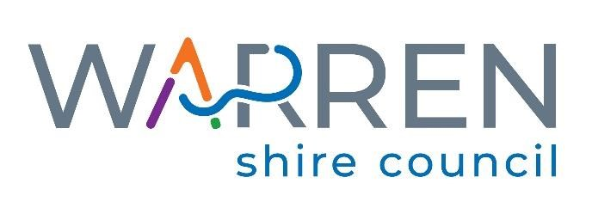

General Information for the Position
of
Heavy Diesel Mechanic

Applications Close: Thursday 27th January 2022 – 4pm

Further Information can be obtained from:

Human Resources - (02) 6847 6600

115 Dubbo Street,
(P.O. Box 6) Phone: (02) 6847 6600
WARREN NSW 2824

SCHEDULE 1

ADVERTISEMENT FOR THE POSITION

Heavy Diesel Mechanic

Position Vacant
Heavy Diesel Mechanic

Warren Shire Council is seeking a motivated and skilled ‘Heavy Diesel Mechanic’ to join their team on a full-time basis.
This position offers an exciting opportunity to expand your knowledge and work on a variety of different machinery. As a ‘Heavy Diesel Mechanic’ you would be part of a small team responsible for the efficient servicing, maintenance and repairs of Council’s plant fleet both in the workshop and in the field.
To be successful in this role, you will possess a Certificate III in Heavy Commercial Vehicle Mechanical Technology, have your Motor Vehicle Tradesperson Certificate (MVTC) and a minimum of 2 years post-trade experience as a Heavy Diesel Mechanic.
Further information on the role, including a full list of essential and desirable criteria, can be found in the information package.

Employment Conditions
- Salary Range: $1,187.70- $1,377.73 per week depending on qualifications and experience (excluding Apprentice)
- Adverse Working Conditions Allowance – currently $16.40/week
- Superannuation per the superannuation guarantee (currently 9.5%)
- 9-day fortnight
- Leave provisions as per the Local Government (State) Award
Applications
Applications are invited and will be received up until 4.00 pm on Thursday, 3rd June 2021.
An information package must be obtained by attending the Administration Office, 115 Dubbo Street, Warren or by visiting Council website https://www.warren.nsw.gov.au/council/employment
All applications should include a Resume and a completed ‘Employment Application Form’ (obtained in the information package) along with two (2) recent references/referees.
Warren Shire Council is an Equal Opportunity Employer and has a Smoke Free Working Environment. The successful applicant will be subject to a pre-employment medical assessment prior to confirmation of employment.
Applications can be lodged:
- Via mail – P.O. Box 6, Warren, NSW, 2824
- In person – 115 Dubbo Street, Warren, NSW, 2824
- Via email – hr@warren.nsw.gov.au
For enquiries, contact Human Resources on (02) 6847 6600. Office reopens 4th January, 2022.

SCHEDULE 2

POSITION DESCRIPTION

Heavy Plant Mechanic

Position Description

Position Title: Heavy Diesel Mechanic
Department: Engineering Services
Classification: Band 2 Level 2 (excluding Apprentice)
Grading: Local Government (State) Award 2020. Progression between Grades 1-5 in line with Council’s Salary System.
Hours of Duty: 9 day fortnight, 38 hour week, 7.00 am Start 4.15 pm Finish. One half hour, 30 minutes, lunch break.
Annual Leave: 4 weeks per year
Immediate Supervisor: Workshop Co-ordinator
Responsible Officer: Divisional Manager of Engineering Services

Position Objectives:
The position of Heavy Diesel Mechanic is one (1) within a team of workers responsible for the efficient repair, monitoring, servicing and maintenance of Council's vehicles, plant and equipment.

It is a requirement of the position that the person be able to work in a team environment and on an individual basis and go about their work in a planned way with a minimum of problems and maximum efficiency.
It is also expected that the incumbent is a person who can lead and motivate others in the team, pass on trade skills to others and solve most problems as they arise without reference to the supervisor.

Qualifications, Licences and Experience:

Essential:
Certificate III in Heavy Commercial Vehicle Mechanical Technology or obtaining.
Motor Vehicle Tradesperson Certificate (MVTC)
Minimum 2 years post-trade experience as a Heavy Diesel Mechanic
Class MR Driver's Licence
Construction Induction Card (White Card)
Welding experience – MIG, Oxy and Stick

Desirable:
TFNSW Light/Heavy Vehicle Examiners Certificate
Refrigerant Handling Licence
First Aid Certificate
Confined Spaces Course
Class HC driver's licence
Certificate of Competency: Forklift

Schedule of Duties:

Be aware of plant and equipment capabilities

Repair and maintain Council plant and machinery

Service Council plant and machinery

Ensure plant, equipment and machinery is fully operative and in safe working order and always operated in a safe and legal way in accordance with all relevant Acts

Ensure that all safety equipment and clothing is used where required in the correct manner

Liaise with immediate Supervisor with regard to daily and weekly works

Initiate instructions to and supervise staff under direct control of the Heavy Diesel Mechanic

Organise daily plant and material requirements, organise stores requisitions

Ensure that all work sites are left in a neat, tidy and safe condition

Prepare insurance reports as required

Attend training sessions associated with the position as required

Ensure that there is no wastage or misuse of resources

Carry out other duties as required that are within the limits of the employee’s skill, competence and training.

Customer Service

Project and promote the image of Council as both positive and efficient through maintaining professional standards and presentation.

Attend to enquiries from internal and external customers promptly and professionally.

Communicate effectively and sensitively with both internal and external customers.

Objectively solve disputes and/or problems that may arise with internal and external customers

Work cooperatively with other organisations

Work Health and Safety Responsibilities
All employees are responsible for WHS at Warren Shire Council and their duties include:

Working in a safe manner without risk to themselves, others, Council’s equipment or the environment;

Reporting all WHS hazards and incidents to their supervisor;

Reporting all injuries and illnesses to their supervisor and the Work Health Safety/Risk Officer within 24 hours;

Providing suggestion, through agreed consultation method, on how to improve WHS issues;

Seeking assistance if unsure of WHS procedures;

Reporting any faulty equipment or plant to their supervisor;

Participate in WHS consultation arrangements in your workplace;

Complying with any Return to Work Plan if injured;

Correctly using all personal protective equipment; and

Complying with emergency and evacuation procedures.

Physical Demands
The position holder is required to be physically fit as they are likely to be exposed to a range of indoor and outdoor workshop conditions as well as field servicing and repair activities, prolonged sitting, and some close eye work.

Key Accountabilities

Adherence to authorised working hours

Adherence to adopted safe working practices

Adherence to adopted works specifications

Control of plant and materials under direct control of the Plant Mechanic

Adherence to adopted policies of Council

Carry out duties as instructed

Report any problems with plant and equipment, mechanical or otherwise, to the Workshop Coordinator

Demonstration of good driving/operating and low maintenance record for plant operated

Advise Workshop Coordinator if unable to attend or complete work or training

Ensure all records are maintained

Ensure harmonious and productive relationships exist with all Council staff

Promote a positive image of Council

Processing of time, plant, contractor and maintenance management system sheets

Mechanical condition of all plant and equipment to such a level to promote a positive image of Council

Expenditure control

Programming of scheduled maintenance and servicing of Council vehicles, plant and equipment

Output Measures

Standard of workmanship

Number of work safety incidents

Record of staff matters

Attendance record

Presentation

Position Skill Descriptors - Trades Band 2, Level 2 (B2 L2):
Authority and accountability: Responsibility as a trainer/co-ordinator for the operation of a small section which uses staff and other resources, or the position completes tasks requiring specialised technical/administrative skills.

Judgement and problem solving: Skills to solve problems which require assessment of options with freedom within procedural limits in changing the way work is done or in the delegation of work. Assistance may be readily available from others in solving problems.

Specialist knowledge and skills: Positions will have specialised knowledge in a number of advanced skill areas relating to the more complex elements of the job.

Management skills: May require skills in supervising a team of staff, to motivate and monitor performance against work outcomes.

Interpersonal skills: In addition to interpersonal skills in managing others, the position may involve explaining issues/policy to the public or others and reconcile different points of view.

Qualifications and experience: Thorough working knowledge and experience of all work procedures for the application of technical/trades or administrative skills, based upon suitable certificate or post-certificate-level qualifications.

Warren Shire Council
Competencies and Skills
Job Title: Heavy Diesel Mechanic
Band: 2
Level: 2

Grade 1
MR Licence
Construction Induction White Card
Certificate III Heavy Commercial Vehicle Mechanical Technology
Motor Vehicle Tradesperson Certificate (MVTC)
Demonstrated post-trade experience repairing heavy plant/vehicles
Basic record keeping
Basic computer skills
Understanding of WHS
Proof that Introduction to New Staff has been read
Knowledge of Anti-discrimination Act
Grade 2
High Risk Work Licence - Forklift
Confined Spaces Training
First Aid Certificate
Refrigerant Handling Licence
Sound mechanical knowledge of Council plant
Ability to interpret workshop manuals, wiring diagrams etc.
Ability to service and maintain small plant (mowers, generators etc)
Ability to service and maintain light plant (cars, utes etc.)
Ability to service and maintain heavy plant (graders, trucks, rollers, backhoes, tractors etc.)
Sound working knowledge and ability to diagnose and repair hydraulic systems
Sound working knowledge and ability to diagnose and repair pneumatic systems
Sound working knowledge and ability to diagnose and repair diesel systems

Warren Shire Council
Competencies and Skills
Job Title: Heavy Diesel Mechanic
Band: 2
Level: 2

Grade 2 (Continued)
Sound working knowledge and ability to diagnose and repair electrical systems
Ability to operate various items of plant for testing and servicing
Working knowledge of pump operation and maintenance
Ability to perform general fabrication and welding work
Knowledge of stores issue and ordering procedures
Ability to initiate and accept responsibility for own work
Demonstrated ability to co-operate and work as part of a team
Demonstrated ability to work unsupervised and ensure quality of own work
Ability to communicate effectively – both oral and written
Ability to maintain accurate records
Proven ability to prioritise tasks and meet deadlines
Ability to understand environmental requirements
Good working knowledge of WHS responsibilities
Grade 3
HC Licence
TFNSW Light Vehicle Examiners Certificate
TFNSW Heavy Vehicle Examiners Certificate
Certificate of Competency – Backhoe
Certificate of Competency – Loader
Ability to train other staff on a one-on-one basis including apprentices
Advanced working knowledge of plant servicing and maintenance
Good working knowledge of sourcing parts through suppliers
Solid working knowledge of plant capabilities
Demonstrated ability to diagnose and repair failures across all of Council’s plant

Warren Shire Council
Competencies and Skill
Job Title: Heavy Diesel Mechanic
Band: 2
Level: 2

Grade 4
Demonstrated ability to communicate and work with other department staff and supervisors
Ability to express ideas and information clearly to others
Proven ability to solve complex problems
Proven ability to design, build and modify equipment successfully
Ability to train, coach and motivate staff
Electrical Test and Tag Certification
Thorough knowledge of the structure of Council and its committees
Demonstrated advanced ability in welding and fabrication
Ability to perform complex repairs on a variety of Council plant
Ability to contribute feedback to assist in the plant replacement program
Ability to supervise
Grade 5
Ability to satisfactorily relieve the Workshop Co-ordinator during extended absences

Acknowledgement
I have read and understood the contents of this position description and agree that they accurately reflect the requirements and responsibilities of this position.

Employee’s Name: _________________________________________________
Signature: ________________________________ Date: ____________________

Supervisor: _________________________________________________
Signature: ________________________________ Date: ____________________

SCHEDULE 3

Employment Application Form

Heavy Diesel Mechanic

Privacy Statement:
As part of the recruitment process Warren Shire Council will be collecting information about you. This information is private information for the Privacy and Personal Information Protection Act. This information will be included in the recruitment file and accessed by Council Human Resources staff and members of the Recruitment Selection Panel. Applicants may request their information be returned to them at the conclusion of the recruitment process.

Have you ever been a serving full-time member of the Australian Defence Force, or a reservist on continuous full-time service?

Personal Details * Required Fields
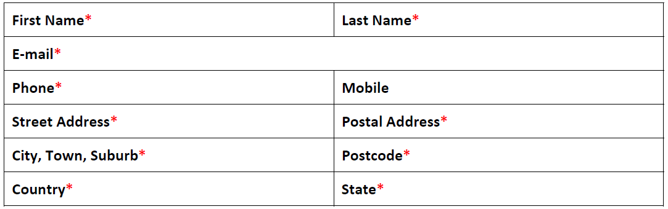
Questions
1. Please indicate your eligibility to work in Australia*
a. Australian/New Zealand Citizen
b. Permanent Resident
c. Current Visa including Visa Class and duration (expiry date)
d. None of the above
2. If you answered Current Visa or None of the above, please provide details of your eligibility to work in Australia including Visa date or issue and any Visa restrictions

3. Have you read and understood the position description and the requirements for the
position that you are applying for? *
a. Yes
b. No
4. Have you ever previously been employed by Warren Shire Council? *
a. Yes
b. No
5. Have you ever been a serving full-time member of the Australian Defence Force, or a reservist on continuous full-time service?
a. Yes
b. No

