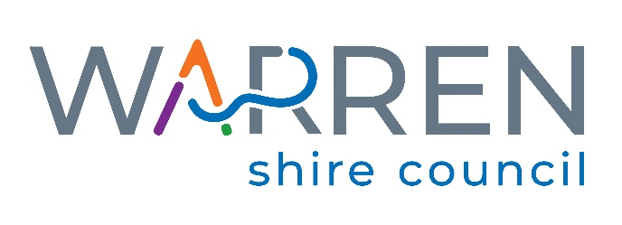

EXPRESSIONS OF INTEREST

INDEPENDENT MEMBER(S) TO JOIN THE AUDIT, RISK AND IMPROVEMENT COMMITTEE

APPLICATION FORM

APRIL 2024

File Ref: A1-3.1

QUESTIONS FOR EXPRESSIONS OF INTEREST APPLICANTS FOR THE WARREN SHIRE COUNCIL AUDIT, RISK AND IMPROVEMENT COMMITTEE (ARIC)

Form Instructions: Form fields have been set up in this document where information is to be typed by you (grey boxes). Select F11 to jump to each form field and please enter the information as required.

- It is expected that the ARIC will meet at least four (4) times per year, up to three (3) hours each meeting at most times virtually. Can you confirm your commitment to fulfill this requirement including providing the appropriate time to prepare before the meetings:

- Please outline your professional and / or formal qualifications:

- Please outline your experience on similar Committees in the local government, public or private sector:

- Please detail your knowledge of the broad activities and services that Councils provide and your awareness of legislation and regulatory requirements:

- Please outline your relevant skills and experience in each of the following:

- Accounting or related financial management and / or audit background with an understanding of accounting and auditing standards in a public sector environment:

- Engineering or related operational management:

- Legal, governance and / or risk management:

- Information and communication technology (ICT):

- Business management:

- Remuneration:

Meeting attendance including required preparation work (maximum $1,000.00 per meeting exclusive of GST):

$ per meeting exclusive of GST.

$ reasonable travel rate to and from Warren exclusive of GST if required.

Details of yearly changes to remuneration if required:

- Name and contact details of two (2) referees:

- Please ensure a copy of your Resume is attached with your Expression of Interest Application Form.

Name:

Postal Address:

Email:

Telephone Number:

Mobile Telephone Number:

Signature:

Date:

Enc. (Resume)

